**NETBEANS**

**First Frame**

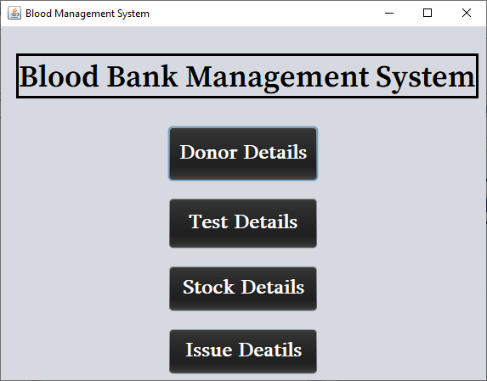

**Donor Detail Button**

Donor_Details so=new Donor_Details();

so.setVisible(true);

this.dispose();

**Test Detail Button**

patient_details so=new patient_details();

so.setVisible(true);

this.dispose();

**Stock Detail Button**

stock_details so=new stock_details();

so.setVisible(true);

this.dispose();

**Issue Detail Button**

Issue_Details so=new Issue_Details();

so.setVisible(true);

**Second Frame**

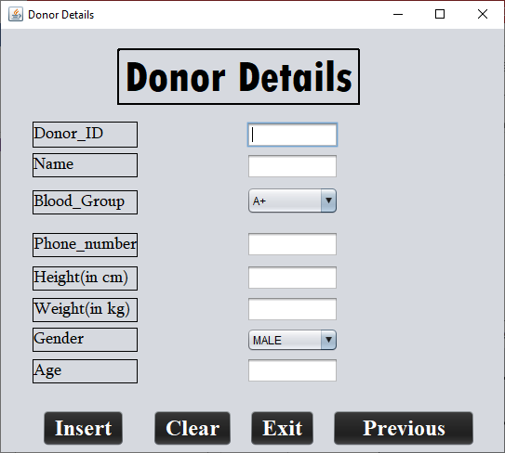

**Insert Button**

try

{

Class.forName("java.sql.DriverManager");

Connection con=DriverManager.getConnection("jdbc:mysql://localhost:3306/bank","root",

null);

Statement stm=con.createStatement();

String id=a1.getText();

String name=a2.getText();

String bgroup=group.getSelectedItem().toString();

long pno=Long.parseLong(a4.getText());

int hieght=Integer.parseInt(a5.getText());

int weight=Integer.parseInt(a6.getText());

String g=gender.getSelectedItem().toString();

int age=Integer.parseInt(a8.getText());

String sql="insert into donor_details values('"+id+"','"+name+"','"+bgroup+"',"+pno+","+hieght+","+weight+",'"+g+"',"+age+");";

String sql2="update stock_details set currentstock=currentstock+1;";

stm.executeUpdate(sql);

stm.executeUpdate(sql2);

System.out.println("Data Inserted");

jButton1.setEnabled(false);

}

catch(Exception ex)

{

System.out.print(ex.getMessage());

}

**Clear Button**

**a1.setText(null);**

**a2.**setText**(null);**

**a4.setText(null);**

**a5.setText(null);**

**a6.setText(null);**

**a8.setText(null);**

**Exit Button**

System.exit(0);

**Previous Button**

Blood_issued so=new Blood_issued();

so.setVisible(true);

this.dispose();

**Third Frame**

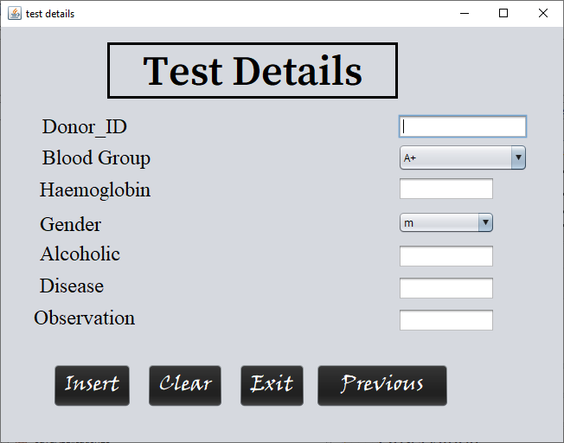

**Insert Button**

try

{

Class.forName("java.sql.DriverManager");

Connection con=DriverManager.getConnection("jdbc:mysql://localhost:3306/bank","root", null);

Statement stm=con.createStatement();

String donorid=id.getText();

String g=bgroup.getSelectedItem().toString();

int haemo=Integer.parseInt(haemoglobin.getText());

String gen=gender.getSelectedItem().toString();

String alcohol=alcoholic.getText();

String d=disease.getText();

String result=observation.getText();

String sql="insert into test_details values('"+donorid+"','"+g+"','"+gen+"',"+haemo+",'"+alcohol+"','"+d+"','"+result+"');";

stm.executeUpdate(sql);

JOptionPane.showMessageDialog(this,"Data Saved ");

jButton1.setEnabled(false);

}

catch(Exception ex)

{

System.out.print(ex.getMessage());

}

**Clear Button**

id.setText(null);

haemoglobin.setText(null);

alcoholic.setText(null);

disease.setText(null);

observation.setText(null);

observation.setText(null);

**Exit Button**

System.exit(0);

**Previous Button**

Blood_issued so=new Blood_issued();

so.setVisible(true);

this.dispose();

**Fourth Frame**

 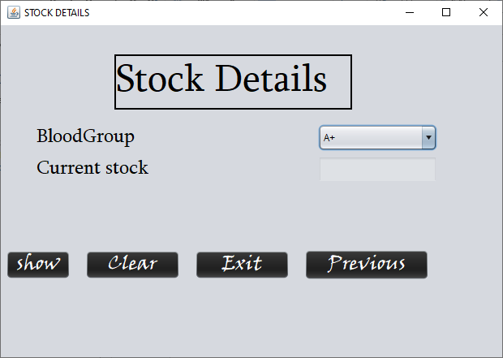

**Show Button**

try

{

Class.forName("java.sql.DriverManager");

Connection con=DriverManager.getConnection("jdbc:mysql://localhost:3306/bank","root",null);

Statement stm=con.createStatement();

String group=bgroup.getSelectedItem().toString();

String sql="select Currentstock from stock_details where bloodgroup='"+group+"';";

ResultSet rs=stm.executeQuery(sql);

rs.next();

String gr=rs.getString(1);

stock.setText(gr);

}

catch(Exception ex)

{

System.out.print(ex.getMessage());

}

**Clear Button**

stock.setText(null);

**Exit Button**

System.exit(0);

**Previous Button**

Blood_issued so=new Blood_issued();

so.setVisible(true);

this.dispose();

**Fifth Frame**

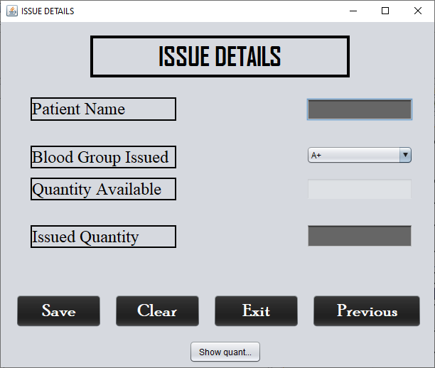

**Show Button**

try

{

Class.forName("java.sql.DriverManager");

Connection con=DriverManager.getConnection("Jdbc:mySql://Localhost:3306/Bank","root",null);

Statement stm=con.createStatement();

String nm=name.getText();

String bgroup=group.getSelectedItem().toString();

int qty=Integer.parseInt(quantity.getText());

int iquantity=Integer.parseInt(issued.getText());

String sql="insert into issue_details values('"+nm+"','"+bgroup+"',"+qty+","+iquantity+");";

stm.executeUpdate(sql);

System.out.println("Data Inserted");

}

catch(Exception e)

{

System.out.print(e.getMessage());

}

**Clear Button**

name.setText(null);

issued.setText(null);

quantity.setText(null);

issued.setText(null);

**Exit Button**

System.exit(0);

**Previous Button**

Blood_issued so=new Blood_issued();

so.setVisible(true);

this.dispose();